# **Lesson Objectives**

1. Find the slope of a line that goes through two points.
2. Know the 4 types of slope.
3. Compute the average rate of change between two points.
4. Identify the slope and *y*-intercept of a linear function,
   1. from a formula.
   2. from a graph.
5. Write the slope-intercept formula of a linear function,
   1. given its slope and *y*-intercept.
   2. given the graph of a line.
6. Graph linear functions in slope-intercept form.
   1. Using MyLab Math graphing tool.
   2. Using graphing calculator.

# Find the **SLOPE** of a Line between Two Points

**Slope Formula:** Given two points (*x*1, *y*1) and (*x*2, *y*2), the slope of the line between them is:

**Slope** =

* **EXAMPLE:** Find the slope, if it exists, of the line containing the pair of points (7,– 4) and (7, – 10).

[1.4.15]

try on calc: 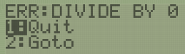 slope is **UNDEFINED**

# The **4 Types of SLOPE**

* **POSITIVE** slope – **UPHILL** (left to right)
* **NEGATIVE** slope – **DOWNHILL** (left to right)
* **ZERO** slope – **HORIZONTAL** line
* **UNDEFINED** slope – **VERTICAL** line

visual display of slope. Cartoon-looking face.
His RIGHT eyebrow is / and beneath it is + sign for his right eye, to indicate positive slope is uphill.
His LEFT eyebrow is \ and beneath it is the - sign, to indicate negative slope is downhill.
His nose is a VERTICAL line with a U beneath it, to indicate vertical lines have undefined slope.
His mouth has zero followed by horizontal line followed by another zero (the zeros look sort of like dimples), to indicate a horizontal line has zero slope.

Positive slope (uphill, left to right) - increasing
Negative slope (downhill, left to right) - decreasing
Zero slope - horizontal line
Undefined slope - vertical linePositive slope (uphill, left to right) - increasing
Negative slope (downhill, left to right) - decreasing
Zero slope - horizontal line
Undefined slope - vertical line

**The “Slope Cheer”**



# **Average Rate of Change (AROC)**

* Used for any function, not just a linear function
* Same formula as SLOPE

**Average Rate of Change** of a function *f* from *x*1 to *x*2 is:

(go on to the next page)

* **EXAMPLE:** Compute the average rate of change from *x*1 to *x*2. Round your answer to two decimal places when appropriate. Interpret your result graphically. [1.4-47]

and

To get the *y*-coordinates for the formula, just plug in *x*-values into the function:

* + 7(– 1) + 3 = – 7 + 3 = – 4 = *y*2

* + 7(– 4) + 3 = – 28 + 3 = – 25 = *y*1

To calculate AROC from *x*1 to *x*2, you must subtract in the correct order. Using the formula:

To interpret this graphically, this means that:  
**the slope of the line passing through (– 4, *f*(– 4)) and (– 1, *f*(– 1)) is 7.**

Look back at the original function: *f*(*x*) = 7*x* + 3 . Notice also where you see a 7 !

* **EXAMPLE:** The following table lists remaining life expectancy, *E*, in years for females of age *x*.

|  |  |  |  |  |
| --- | --- | --- | --- | --- |
| *x* (yr) | 50 | 60 | 70 | 80 |
| *E* (yr) | 33.8 | 25.2 | 18.1 | 13.2 |

Find the average rate of change of remaining life expectancy between the ages of 50 and 60.  
(type an integer or decimal). Then, interpret this value. [1.4.103]

Average Rate of Change (AROC) =

This means that for each 1-year increase between the ages of 50 and 60 years,

**the remaining life expectancy decreases, on average, by 0.86 years.**

(you don’t use a negative sign there because of the context word “decreases.”)

# Identify the **SLOPE** and ***y*-INTERCEPT** of a Linear Function

## **From a formula**

**Linear Function:** can be written in the form ***f*(*x*) = *m x* + *b***   
 is written in **slope-intercept form**, where ***m*** is the **slope**, and ***b*** is the ***y*-intercept (0,*b*)** .

* **EXAMPLE:** The amount of money, in dollars, raised each year by a band booster club can be estimated by the function , where *x* is the year with   
  . What is the slope of the graph of *f*? [1.4-54]

The formula is given in slope-intercept form, so the slope is **198**.

The slope is the coefficient of *x*, provided you are in slope-intercept form.

* **EXAMPLE:** A linear function *f* can be written in the form *f*(*x*) = *m* *x* + *b*.   
  Identify *m* and *b* for the given [1.4.3]

This can be rewritten as, so ***m* = – 2 and *b* = 0**.

* **EXAMPLE:** Write a formula for a linear function *f* whose graph satisfies the given conditions.

Slope 24 and passes through the origin. [1.4.49]

The origin is the point (0,0), so the *y*-intercept is *b* = 0, with the given *m* = 24.

So, a formula for a linear function satisfying the given condition is *f*(*x*) = **24*x***

(go on to the next page)

## **From a graph**

* **EXAMPLE:** Identify the slope, *y*-intercept, and *x*-intercept. [1.4-16]

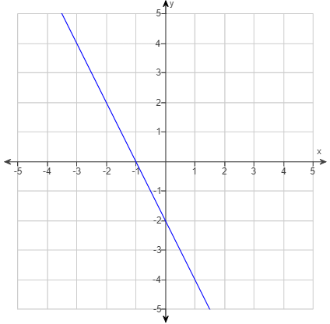 Slope

We’re not going to use the coordinate part of the formula; rather, we are going to find rise and run directly in the graph.

Pick any 2 points in the graph that you can easily identify their location (coordinates).

Don’t “eyeball” it – make sure the graph passes directly through two grid lines that intersect!Since we need to identify them anyway, Let’s use the ***x*-intercept**  and the ***y*-intercept**

If we go high-to-low,

**rise = DOWN 2**

**run = RIGHT 1**. So the slope is

Or, if we go low-to-high,

**rise = UP 2**

**run = LEFT 1**. So the slope is

The slope is the same regardless of the direction you calculate the slope.

Notice also that in the graph, the line is going DOWNHILL, which means the slope will be NEGATIVE.

This is a way to “sanity check” your calculation for slope.

(go on to the next page)

# Write the **Slope-Intercept Form** of a Linear Function

## **Given its slope and y-intercept**

* **EXAMPLE:** Write a formula for a linear function *f* whose graph satisfies the condition slope and *y*-intercept . [1.4.47]

A linear function is of the form: or

The slope *m* is given, so and the *y*-intercept is given, so .

A formula for a linear function satisfying the given condition is .

## **Given the graph of a line**

* **EXAMPLE:** Write the equation of the line whose graph is shown. [1.4-17]

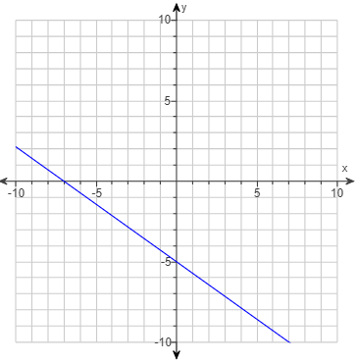

Equation of a line always needs:

Slope and *y*-intercept

But you actually do them in reverse order when you have a graph.

*y*-intercept = So ***b* = – 5**

We need a second point to do slope, so use the *x*-intercept =

Slope , going low-to-high is:

So, equation of the line

Is

(go on to the next page)

# Graph a Linear Function **Slope-Intercept Form**

## **Using *MyLab Math* graphing tool**

* **EXAMPLE:** Graph the linear function by hand. Identify the slope and *y*-intercept.

[1.4.59]

What is the slope of the graph of *g*? The slope is

What is the *y*-intercept of *g*? The *y*-intercept is so, *b* = 0.

Use the graphing tool to graph the function.

1. Press the button **“Click to enlarge graph”**

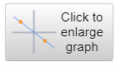

1. Select the **“line tool”**

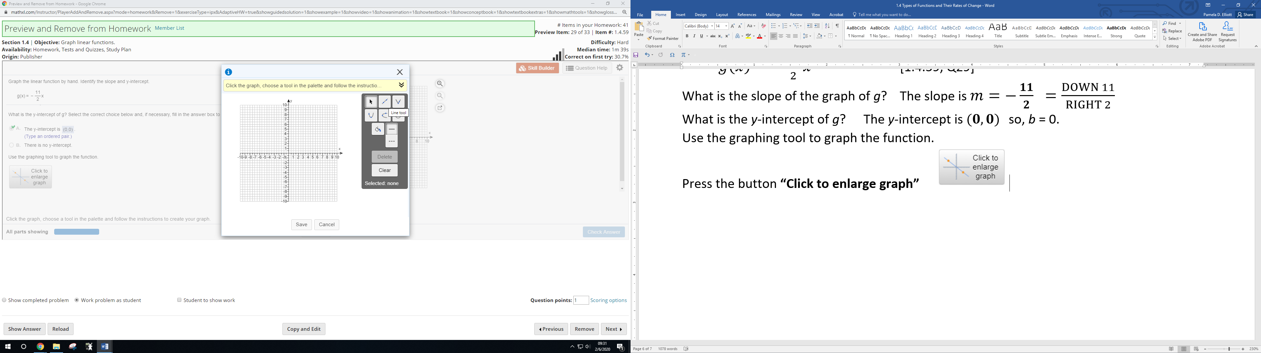

1. Click the graph to plot the first point on your line, which is the *y*-intercept (0,0).

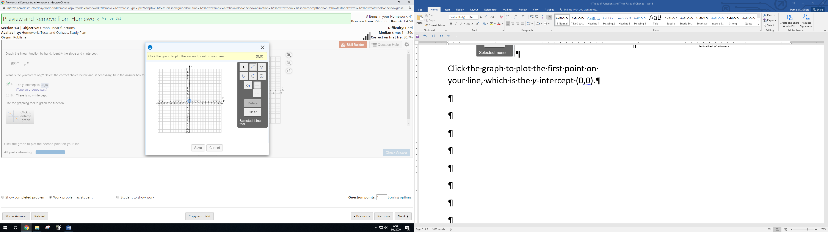

1. Click the graph to plot the second point on your line.

Keep your mouse on your *y*-intercept and use the ARROW keys to do rise and run for your slope.

* Move DOWN 11 grid lines (you don’t need to go to the number 11)
* Move RIGHT 2 grid lines (you don’t need to go to the number 2)
* Press ENTER and line turns gold

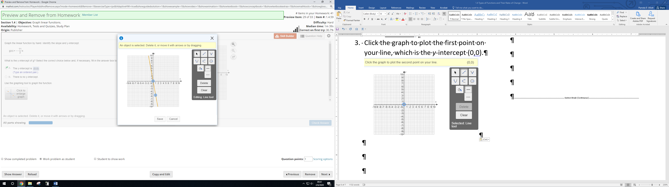

1. Press the **SAVE** button, followed by the **CHECK ANSWER** button. Line is blue.

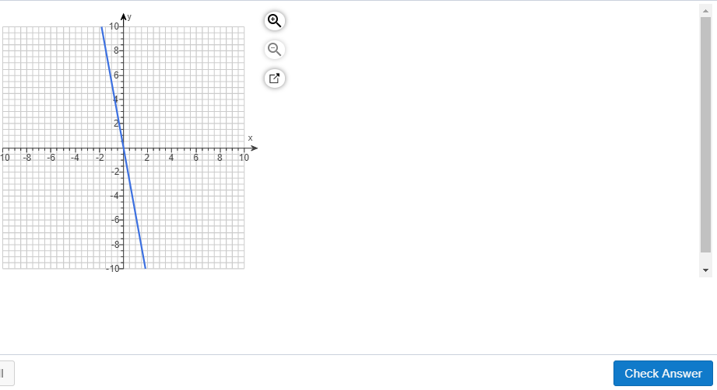

## **Using graphing calculator (TI-84/83 Plus)**

You can use your graphing calculator to verify that you have the correct graph.

We will use the previous example to graph on the calculator.

[1.4.59]

1. Press ***Y*=** button at upper left of calculator. 

Clear out any functions, if needed, by pressing **CLEAR**. 

1. Enter your function rule next to the **Y1=** at the top. Use parentheses for fraction, or use the fraction feature on the TI-84, if you want to.



Make sure Plot1, Plot2, and Plot3 are not highlighted at the top. If they are, move cursor up to it and press ENTER to turn it off.

1. Before you press **GRAPH**, check the graphing area provided either in the problem or the answer. Look at the SCALE – how are the *x*-axis and *y*-axis labeled.

Press **WINDOW**   and adjust your *x*-axis and *y*-axis values, if needed.

 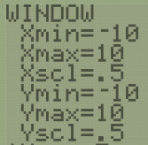

1. Now you can press **GRAPH**.

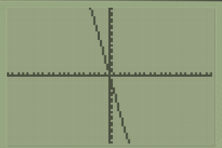

Sources Used:

1. 4 Types of Slope, Mr. Slope Guy: <http://mrssorensensblog.weebly.com/uploads/5/7/3/6/57368065/7_-_slope.pdf>
2. Pearson MyLab Math *College Algebra with Modeling and Visualization, 6th Edition*, Rockswold
3. Wabbitemu calculator emulator version 1.9.5.21 by Revolution Software, BootFree ©2006-2014 Ben Moody, Rom8x ©2005-2014 Andree Chea. Website <https://archive.codeplex.com/?p=wabbit>